Primoria Competition Report
An AI-native learning workspace for adaptive, long-horizon education
Prepared by Primoria Team: Fan Zhang and Junjie Zhou
Submission Date: July 1, 2026
Project Field | Content
Project Name | Primoria
Project Type | AI education / adaptive learning / agent application
Repository | https://github.com/ZhangJunQiu-Alan/Primoria
Team / Authors | Primoria Team: Fan Zhang, Junjie Zhou

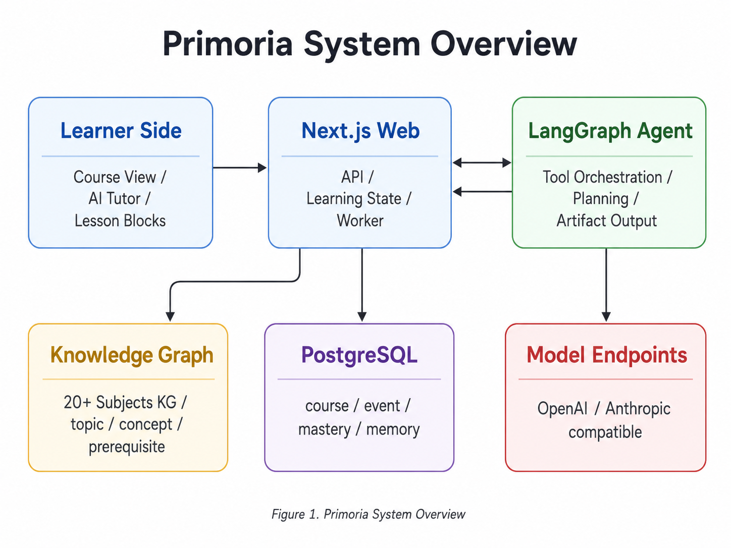
Executive Summary
Primoria is an AI-native learning system designed for long-term learning rather than one-time content generation. It combines a learner's goal, position in the knowledge graph, concept-level mastery, quiz evidence, learning events, and long-term memory into a single adaptive loop. The system continuously decides what should be taught next, how deeply it should be taught, whether remediation is required, and which material can be reviewed quickly or skipped.
The project is implemented as a full-stack monorepo using Next.js, React, CopilotKit, LangGraph, PostgreSQL, Drizzle ORM, and a multidisciplinary knowledge graph. It supports natural-language learning-goal positioning, course-outline generation, lazy lesson generation, interactive learning blocks, concept-level quizzes, evidence collection, mastery updates, and remedial lesson insertion. Compared with ordinary AI chat tools, Primoria connects large language models to an observable, recoverable, and continuously adjustable learning system.
Keywords: AI education, adaptive learning, knowledge graph, AI agent, LangGraph, CopilotKit, Next.js, PostgreSQL, interactive visualization
Contents
1. Competition and Team Introduction
2. Project Background
3. Technical Implementation
4. Project Innovations
5. Implementation Status and Roadmap
6. Conclusion
1. Competition and Team Introduction
Primoria is a competition project developed by the Primoria team, with Fan Zhang and Junjie Zhou as the main contributors. Within a limited competition window, the team implemented a real, runnable, deployable full-stack AI learning system rather than stopping at a concept demo or static interface prototype.
The project sits at the intersection of artificial intelligence, software engineering, human-computer interaction, and educational technology. Its goal is to build a complete AI application: the frontend delivers the learning experience, the backend manages course generation and learning state, the agent layer orchestrates tools and intelligent interaction, and the database persists long-term learning evidence.
2. Project Background
2.1 Problem Context
Many AI education products still behave like one-shot content generators. A learner enters a prompt such as “teach me calculus” or “explain binary search,” and the system immediately generates an explanation, a set of exercises, or a course outline. Real learning, however, is not completed through a single generation step. Learners develop different misunderstandings across different concepts, and new evidence appears through practice, questions, feedback, and review.
Problem | Impact
Lack of long-term state | The system does not know what the learner has studied before, where they are weak, or what kind of explanation they prefer.
Lack of knowledge structure | Course paths are often improvised by the model and may ignore prerequisite relationships or learning order.
Lack of evidence loop | Quizzes, feedback, and lesson completion do not reliably affect the next teaching decision.
Limited interactivity | Most content remains static text, which is weak for dynamic mechanisms, variable relationships, and abstract processes.

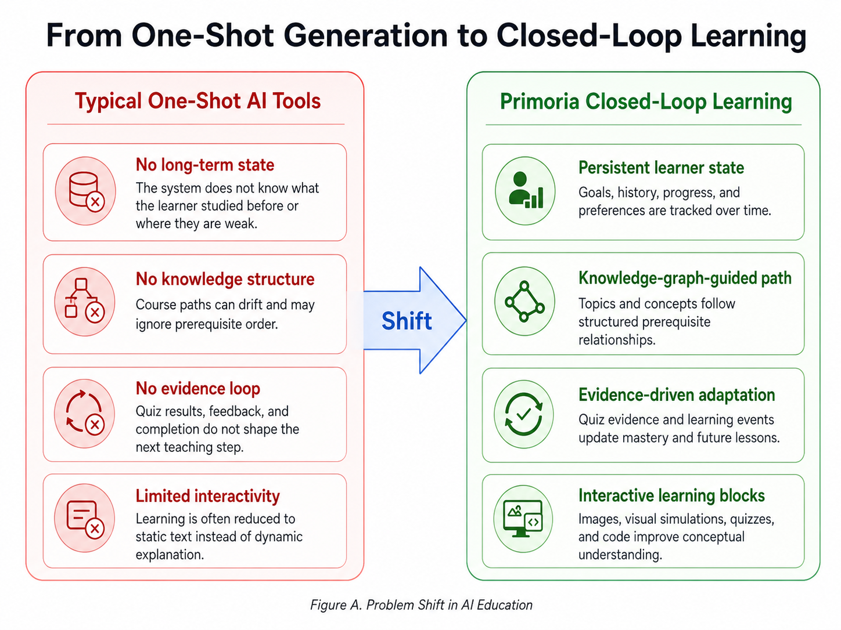
Figure 2. From one-shot generation to closed-loop learning
Primoria is designed around these gaps. It places course generation, knowledge graphs, the AI tutor, learning evidence, and long-term memory in one system so that AI does not merely answer questions; it helps organize the full learning process.
2.2 Project Goal
Primoria's goal is to generate and maintain an adaptive course path tailored to each learner's current understanding.
- Learning goal positioning: a learner describes a goal in natural language, and the system locates the subject, topic, and starting concepts in a multidisciplinary knowledge graph.
- Course path generation: the system generates the course outline according to knowledge-graph order rather than relying entirely on free-form model generation.
- Lazy lesson generation: the first lesson is generated immediately, while later lessons are generated as learning progresses to reduce waiting time and wasted generation cost.
- Interactive learning content: the system generates visual, image, quiz, code, and transfer blocks when they improve understanding.
- Learning evidence collection: quiz results, lesson completion, goal-positioning results, and conversational feedback are recorded as structured events.
- Concept mastery updates: concept-level mastery is maintained to decide whether to skim, teach fully, or remediate.
- Remedial lesson insertion: when a knowledge gap is detected, the system can insert a remedial lesson into the original learning path.
- Long-term memory: fragmented learning events are distilled asynchronously into learner profiles and retrievable learning memories.
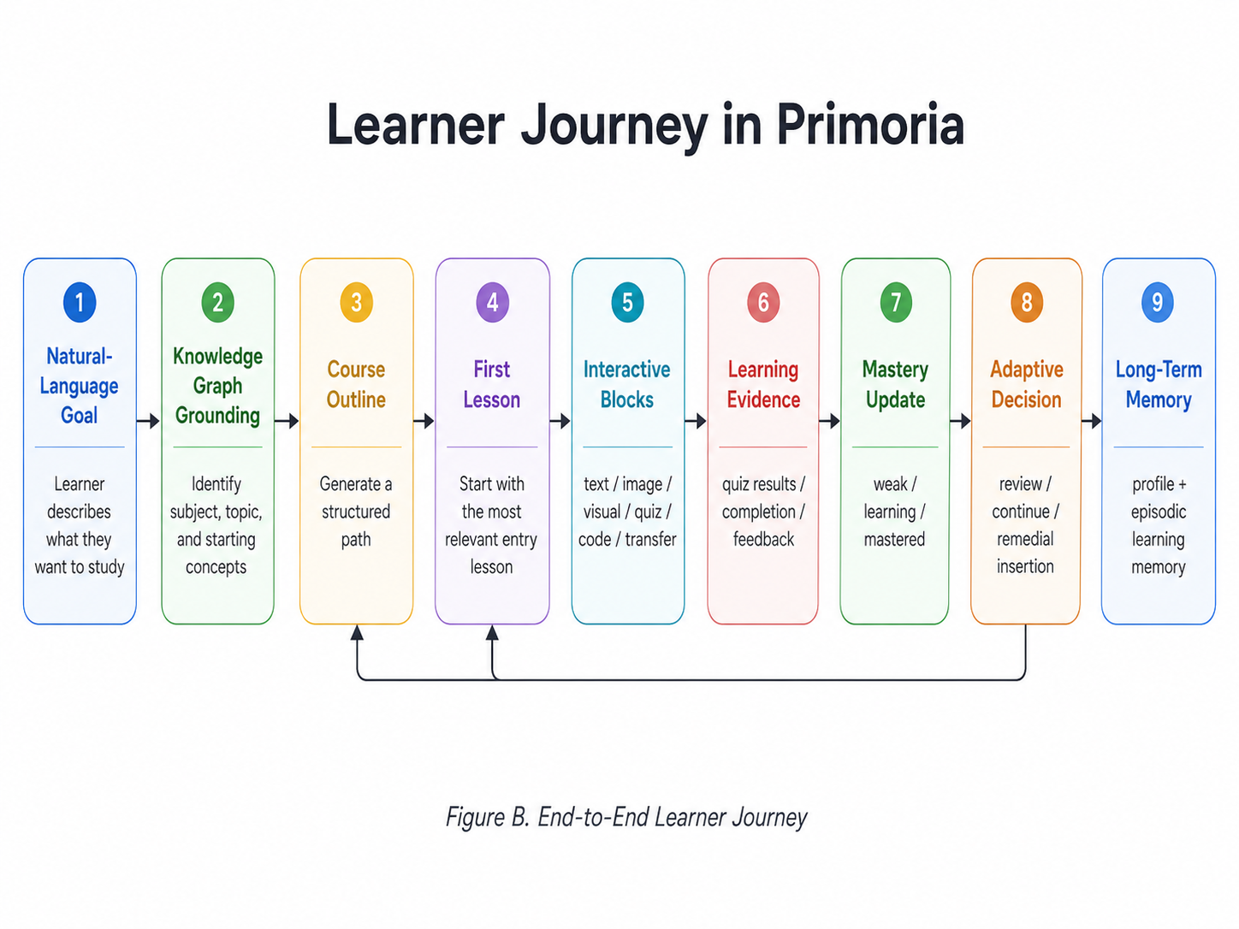
Figure 3. End-to-end learner journey in Primoria
2.3 Target Users
Primoria serves students and self-directed learners who need systematic support for complex knowledge, especially in scenarios such as:
- learning mathematics, physics, algorithms, machine learning, or other subjects with strong prerequisite relationships;
- wanting AI to organize a learning path instead of only answering isolated questions;
- needing interactive visualization to understand abstract mechanisms;
- using quiz performance to adapt learning depth, review, and remediation.
3. Technical Implementation
Source code repository: https://github.com/ZhangJunQiu-Alan/Primoria
Primoria is a full-stack monorepo. Its core technology stack includes:
Layer | Technology
Frontend application | Next.js, React, Tailwind-style UI
AI tutor interface | CopilotKit
Agent orchestration | LangGraph, LangChain, deepagents
Database | PostgreSQL, Drizzle ORM, postgres driver, Supabase
Knowledge graph | Multidisciplinary KG JSON with topic, concept, and prerequisite structures
Type contracts | TypeScript, Zod
Interactive rendering | Sandboxed iframe, HTML/CSS/JS artifacts, THREE, Matter.js, Chart.js, d3, p5, Mermaid
Engineering tools | pnpm workspaces, tsx, Playwright, ESLint

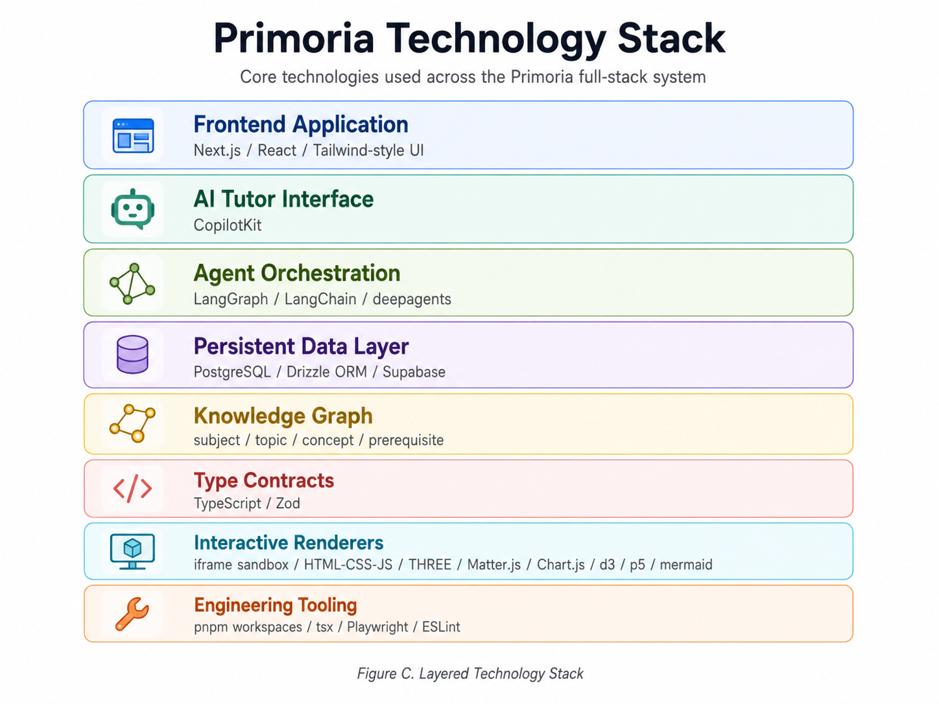
Figure 4. Primoria technology stack
3.1 System Overview
The key design principle is that the web application owns user state and database writes, while the agent layer owns tool orchestration and intelligent interaction. The agent does not directly mutate the database. Instead, it expresses intent through a tool protocol, and the web side performs course creation, state updates, and persistence.
This separation is important for both reliability and product control. The learner sees a natural tutor experience, but the system behind it remains structured: course records, lesson blocks, quiz attempts, concept mastery, generation jobs, and memory extraction all have explicit owners. The architecture therefore supports experimentation with different models and agent tools without turning the database into an uncontrolled side effect of model output.
3.2 AI Tutor Agent Architecture
Primoria's AI tutor is not a simple chatbot. It can call tools for learning-goal positioning, course-card creation, visualization planning, interactive component rendering, STEM-specific tools, and quiz or artifact output.
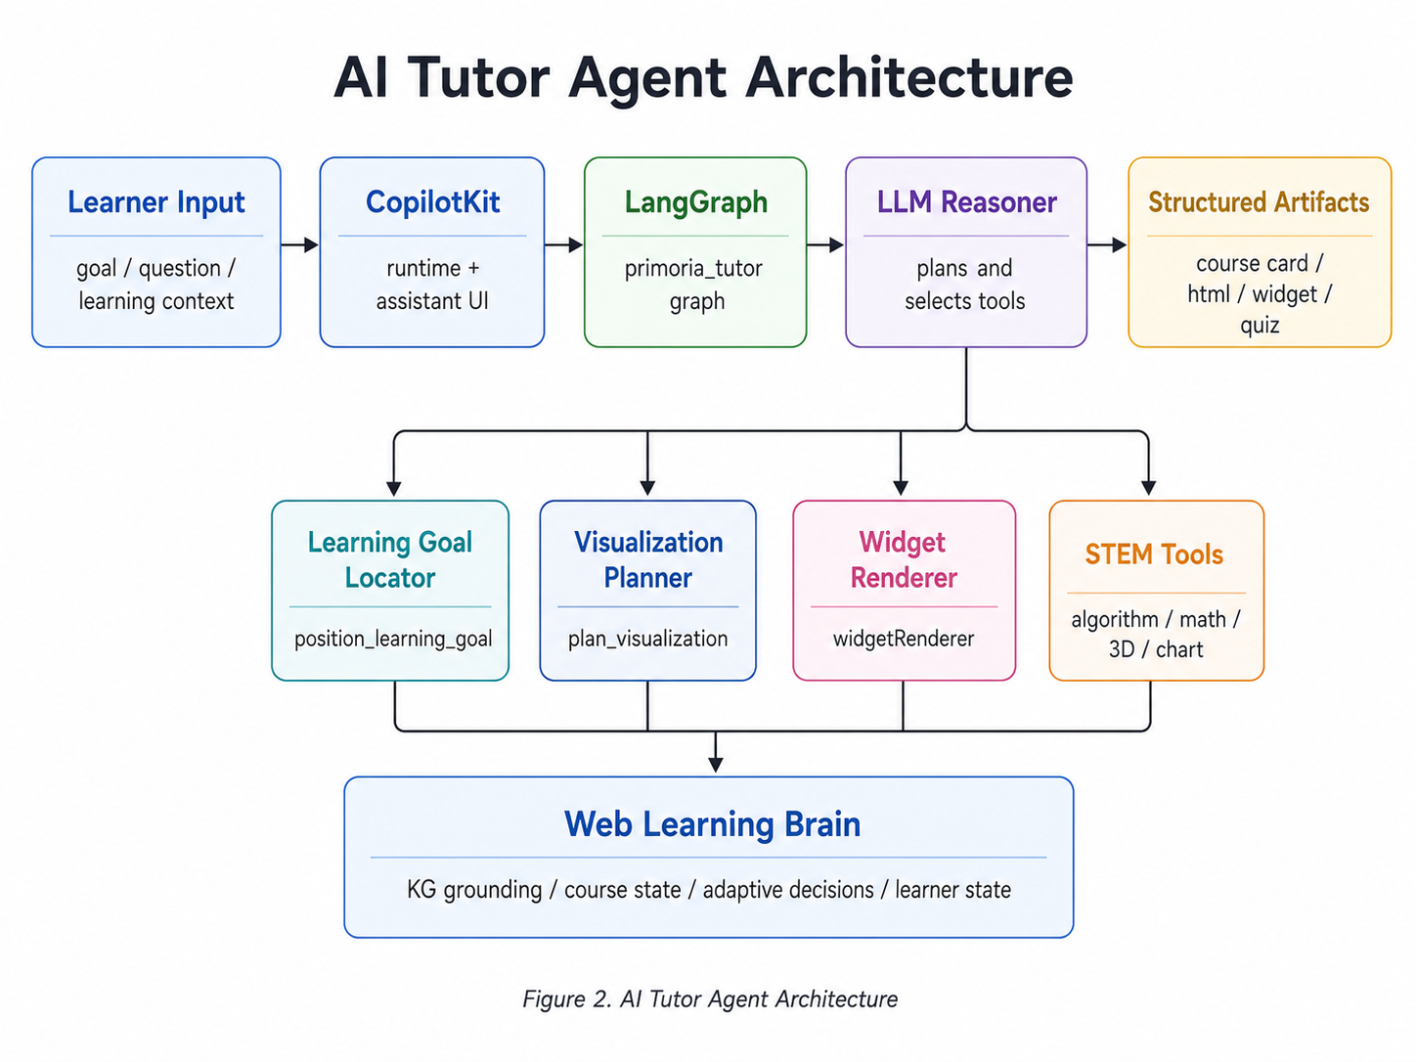
Figure 5. AI tutor agent architecture
This architecture provides four advantages:
- Controlled tools: the model cannot write arbitrary database records and can only express intent through predefined tools.
- Structured outputs: the frontend receives artifacts instead of uncontrolled plain text.
- Extensible teaching behavior: new renderers, evaluators, or course-editing tools can be added later.
- Centralized learner state: courses, mastery, learning events, and memory remain managed by the web application.
3.3 Course Generation and Knowledge-Graph Grounding
Course generation starts with knowledge-graph positioning. After the learner enters a goal, the system identifies the subject and starting topic in a multidisciplinary knowledge graph, then generates the course outline and first lesson.
The grounding layer gives Primoria a durable instructional spine. Instead of asking the model to invent an entire curriculum from scratch, the system uses graph structure to anchor the path and then asks the model to generate teachable lesson content inside that path. This makes the course easier to inspect, revise, resume, and adapt after new evidence is collected.
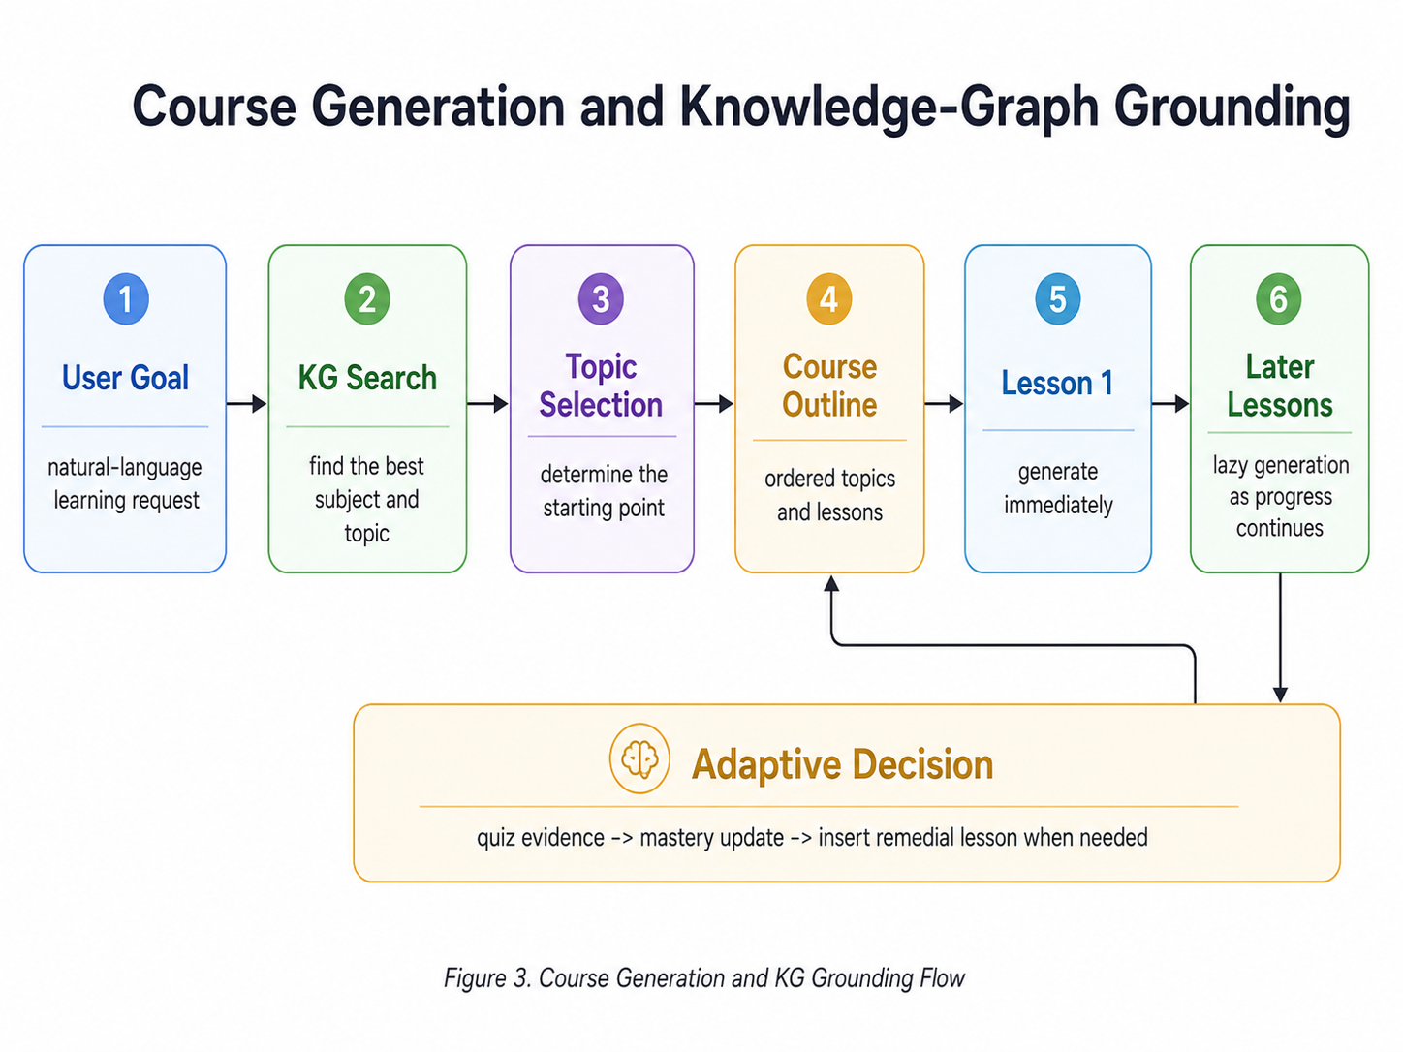
Figure 6. Course generation and knowledge-graph grounding flow
The knowledge-graph layer contains:
- subject: disciplines such as calculus, physics, data structures, and algorithms;
- topic: chapter-level units in a learning path;
- concept node: the smallest concept that can be independently checked through a quiz;
- prerequisite edge: relationships that define dependency order;
- default_order: the default topic sequence within a subject.
Lessons reference KG topic and concept IDs instead of copying the entire graph. This keeps course content grounded in a stable structure and makes later remedial insertion easier.
3.4 Lesson Block Generation
A Primoria lesson is not a single long article. It is composed of learning blocks, and each block represents a teaching action.
Block Type | Purpose
text | Concept explanation, hook, roadmap, and summary
image | Static cognitive anchor for structure recognition, scene intuition, and analogy
visual | Interactive visualization for dynamic mechanisms, variable relationships, and process observation
quiz | End-of-concept check for each concept
code | Programming, algorithms, software engineering, and numerical-computing practice
transfer | Integrated application that combines multiple concepts

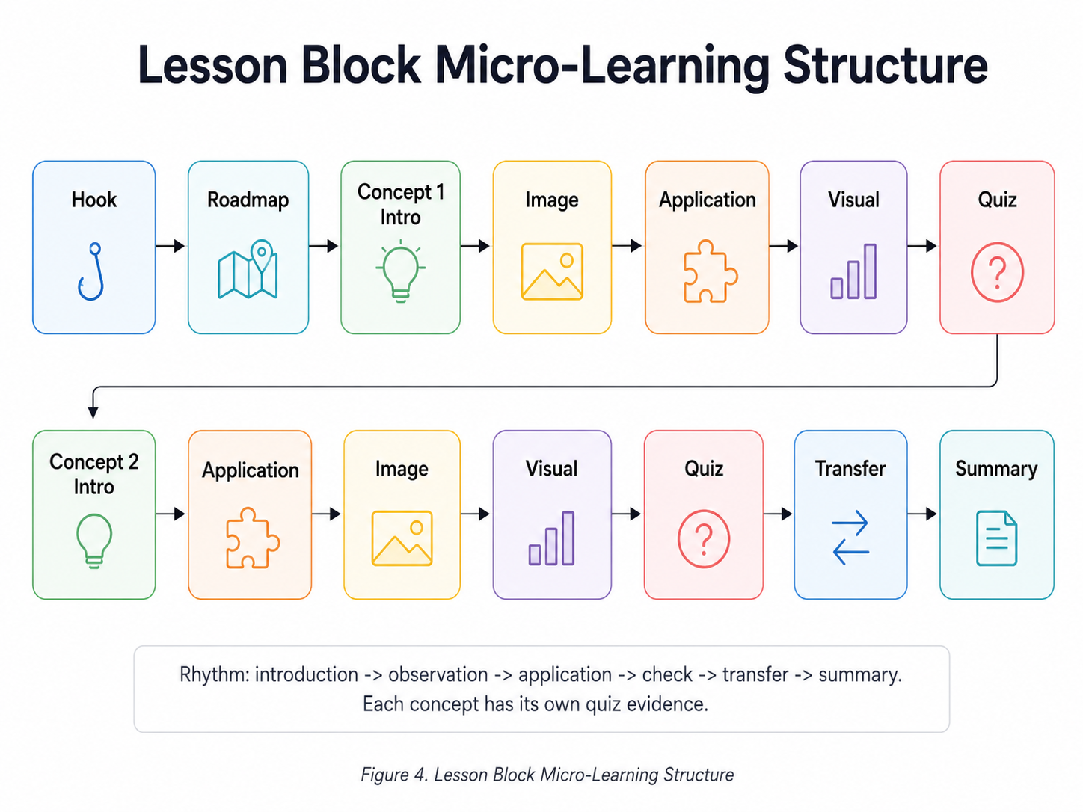
Figure 7. Lesson block micro-learning structure
For a two-concept lesson, the system typically recommends 13 to 15 blocks. This creates a micro-loop of introduction, observation, application, check, transfer, and summary, avoiding the common failure mode where AI courses become long streams of text.
3.5 Interactive Component Rendering
Interactive visual blocks are central to Primoria's learning experience. Model-generated HTML, CSS, and JavaScript are not inserted directly into the main page. Instead, they run inside a sandboxed iframe after stream stability checks.
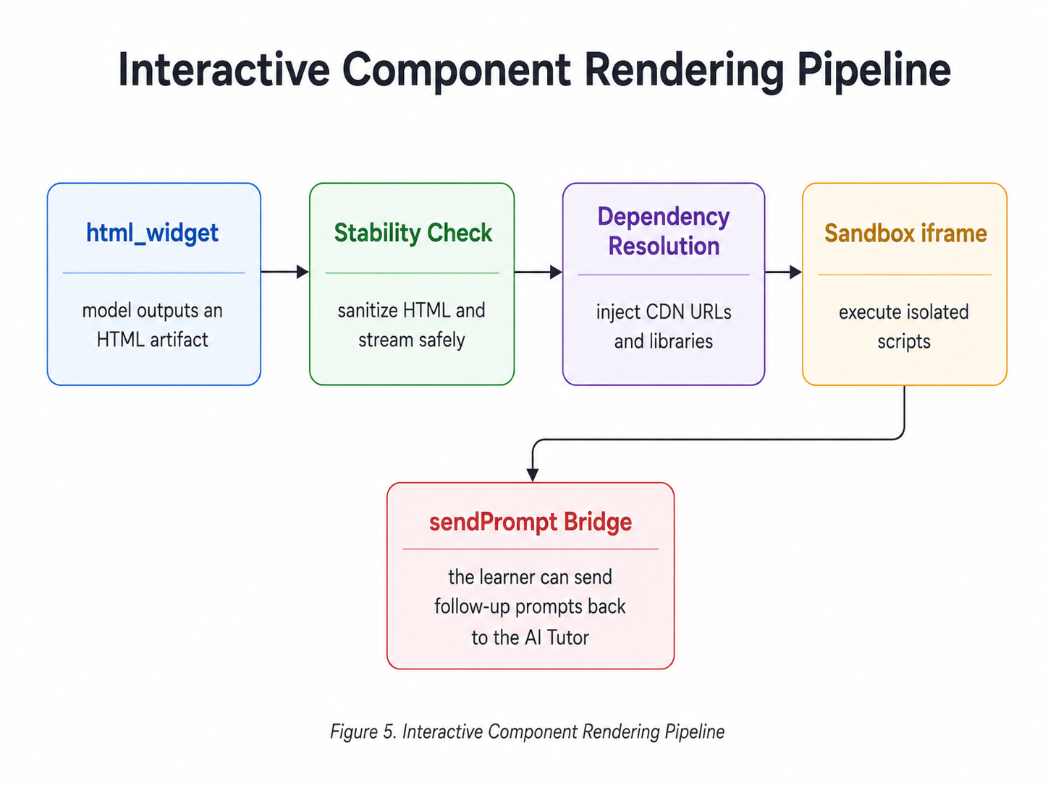
Figure 8. Interactive component rendering pipeline
The sandboxed design addresses three issues:
- Security: model-generated scripts cannot pollute the main application.
- Stability: scripts execute after streamed content becomes stable, reducing runtime crashes.
- Extensibility: different subjects can use different visualization libraries such as THREE, Matter.js, d3, Chart.js, p5, and Mermaid.
3.6 Learning Evidence and Adaptive Feedback Loop
Primoria records key events during the learning process and uses them for mastery updates and next-step course decisions.
The feedback loop is designed to make the learning system recoverable. If a learner misses a concept quiz, asks repeated questions about the same idea, or completes a lesson quickly with strong evidence, those signals can be stored and used later. In other words, Primoria treats learning behavior as system data rather than ephemeral chat context.
Data | Purpose
learningEvents | Record quiz, lesson completion, positioning, feedback, and other learning events
quizAttempts | Store quiz answers and results
userConceptMastery | Maintain each learner's concept-level mastery state
learnerProfiles | Store learner profile and preferences
extractorJobs | Distill learning events asynchronously into long-term memory
lessonGenerationJobs | Manage lesson-generation tasks with recovery and retry support

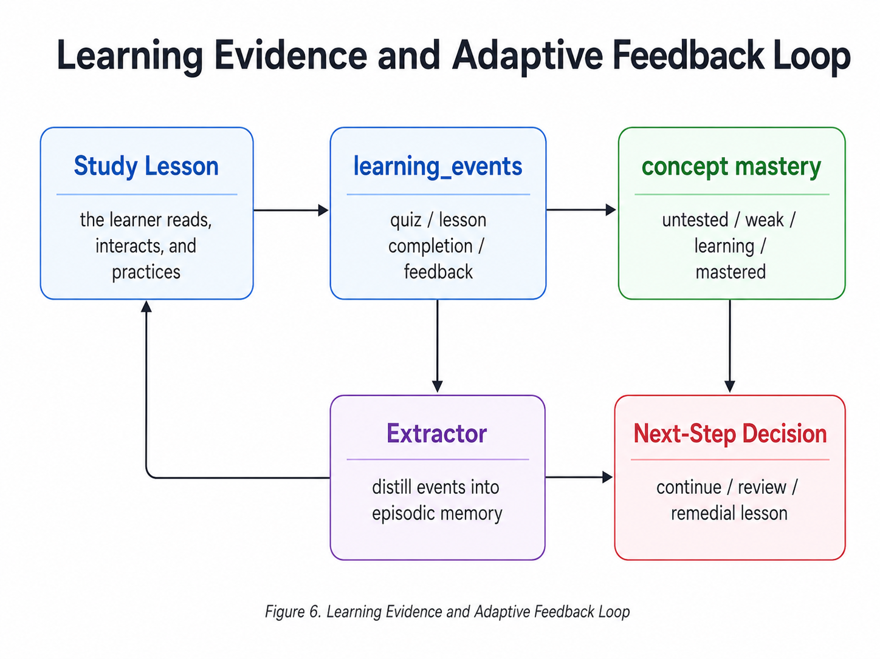
Figure 9. Learning evidence and adaptive feedback loop
Concept mastery is updated from quiz evidence and rule-based logic rather than the LLM's subjective judgment. The LLM generates content and distills semantic memory, while evaluation and remediation decisions are driven by structured evidence as much as possible.
3.7 Database Design
The system uses PostgreSQL and Drizzle ORM. The core data model is organized around several categories:
- Identity and session: users, login identities, sessions, and settings.
- Courses and lessons: course records, lesson blocks, and course-editing events.
- Learning progress: learning events, quiz attempts, and concept mastery.
- Generation tasks: lesson-generation jobs and checkpoints.
- Long-term memory: learner profiles, learner facts, and extractor jobs.
- AI tutor conversation: Copilot chat threads and messages.
- Future workspace foundation: workspaces, workspace agents, agent runs, and agent memories.
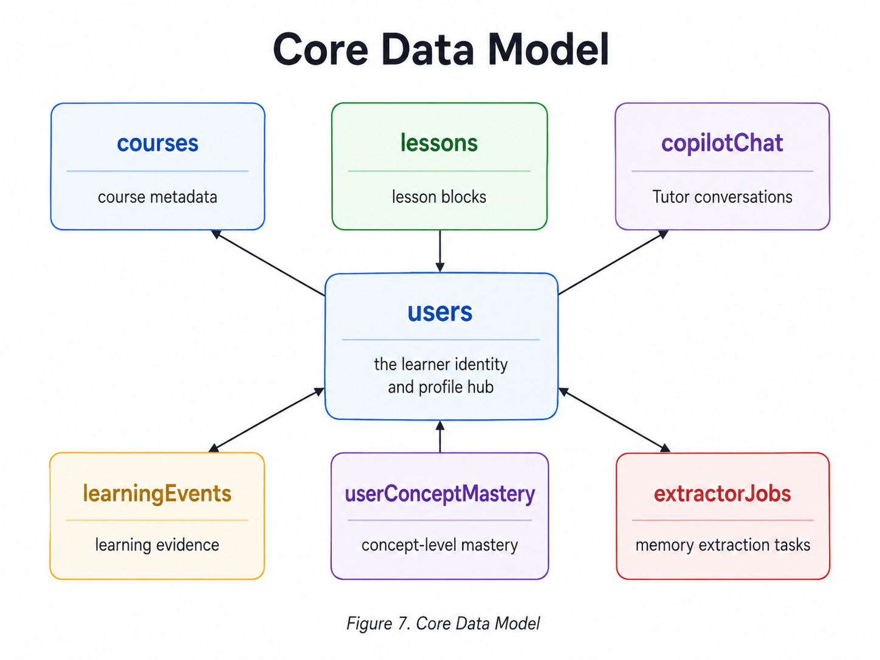
Figure 10. Core data model
4. Project Innovations
4.1 From One-Shot Generation to Long-Term Learning Loops
Primoria does not only generate course content. It connects learning goals, course paths, quiz evidence, mastery, remedial lessons, and long-term memory into one loop. Each learning session produces new evidence that can affect the next teaching decision. This changes the role of AI from a text generator into a participant in an ongoing learning system.
4.2 Knowledge-Graph-Constrained Course Paths
The course path is constrained by topics, concepts, and prerequisite relationships in the knowledge graph rather than being generated freely by the LLM. This improves ordering stability and provides a structural foundation for adaptive remediation. It also makes the course auditable: the system can explain which topic or concept a lesson belongs to instead of hiding the learning path inside prose.
4.3 Tool-Based Agent Instead of Plain Chat
The AI tutor uses LangGraph to call structured tools and outputs artifacts for frontend rendering. It can talk with the learner, create course entry points, plan visualizations, generate interactive components, and trigger learning-goal positioning. The result is a tutor that behaves conversationally while still producing structured objects the application can store, render, and recover.
4.4 Interactive Visual Blocks
Primoria supports interactive visuals inside lessons. Compared with static text or static images, visuals can show variable relationships, dynamic processes, and abstract mechanisms, making them especially useful for algorithms, physics, mathematics, and engineering. This gives the system a richer teaching vocabulary than explanation plus quiz alone.
4.5 Evidence-Driven Mastery Updates
Concept mastery is maintained from quiz evidence and rule-based updates, preventing the system from marking a learner as mastered simply because they say they understand. This creates more stable evaluation and better downstream adaptive decisions. It also opens the door to longitudinal progress views, review scheduling, and personalized notes based on observed learning evidence.
5. Implementation Status and Roadmap
5.1 Completed Work
The competition implementation covers the main product path from learner intent to course creation, lesson delivery, interaction, assessment, and persistence. The completed work is not limited to UI screens; it includes the state model, agent interface, generation jobs, learning evidence, and deployment foundations needed for a real full-stack system.
- End-to-end adaptive learning flow: Primoria can take a natural-language learning goal, locate the relevant knowledge-graph area, generate a course outline, create the first lesson, and preserve the course so the learner can return to it later.
- AI tutor and structured agent interface: the learning experience includes a CopilotKit-powered tutor connected to LangGraph tool orchestration. The tutor can guide the learner conversationally while producing structured artifacts that the application can render and persist.
- Knowledge-graph-grounded curriculum model: the system uses subjects, topics, concepts, prerequisite edges, and default ordering to make course paths more stable than free-form generation. This foundation supports remediation and future progress analytics.
- Interactive lesson workspace: the Course Reader / Course Tutor surface supports block rendering, interactive visuals, quizzes, selected-text Q&A, voice tutor interactions, feedback capture, and analogy insertion. This turns lessons into a mixed learning environment rather than a static article.
- Learning evidence, mastery, and memory foundation: quiz attempts, learning events, concept mastery, learner profiles, memory extraction jobs, and source-grounded retrieval are represented in the data model, allowing future teaching decisions to be based on observed learning behavior.
- Platform and deployment readiness: the implementation includes account/session foundations, Chinese and English interface support, workspace collaboration, agent discovery and creation flows, CI/CD preparation, staging and production promotion structure, release manifests, and a self-hosted deployment path.
5.2 Next Development Priorities
The remaining work focuses on turning the strong prototype loop into a smoother production learning experience. The priority is not to add unrelated features, but to make adaptation, remediation, memory, and context handling more dependable.
- Complete the remedial-course interaction loop after all concept quizzes in a lesson are finished, including remedial reasons, user choice, cross-lesson navigation, and correct “continue learning” entry behavior.
- Inject concept mastery into lesson-building prompts so mastered concepts are skimmed or skipped, while weak or untested concepts receive full instruction and richer examples. Lessons should adjust depth but never become empty.
- Improve the quality of layered memory distillation, especially the core learner profile, explanation preference, learning pace, depth preference, cognitive blockers, and episodic memory.
- Improve lesson-block generation stability so image, visual, quiz, and transfer blocks follow the 13 to 15 block recipe and alternate dynamic and static content cleanly.
- Improve the AI tutor's understanding of the current course, lesson, block, and concept context.
- Increase interactive visualization stability across screen sizes and themes.
5.3 Roadmap
Phase | Direction | Goal
P0 | Personal learning loop | Stabilize goal positioning, course creation, learning, evaluation, remediation, and memory distillation.
P1 | Classroom / workspace | Deepen teacher, student, assignment, and class-learning analytics on top of the existing workspace foundation.
P2 | Multi-agent collaboration | Improve agent capability declarations, confidence, and task execution on top of the existing Marketplace and agent-draft foundation.
P3 | Collective intelligence | Create a content flywheel through shared courses, feedback ranking, and system-level learning.

Near-term iteration priorities:
- Code practice inside AI conversations, allowing learners to edit and run code examples directly in the tutor flow.
- Quiz hints, retry flows, and misconception analysis so wrong answers become useful evidence for review and remediation.
- Cross-disciplinary prerequisite support, allowing remedial lessons to bridge related subjects when a missing concept belongs outside the current course.
- Cold-start onboarding for users with no history and initial learner-profile collection.
- Retrieval improvements for broad goals, aliases, and expanded topics so user materials can ground learning more reliably.
- Perfect Notes: distill the full course journey by concept into review artifacts, including the explanation that finally worked, questions asked, typical mistakes, mastery state, and recommended review problems.
- Personal learning memory retrieval, allowing useful past learning moments to inform future course creation and review.
- Galaxy-style course-path visualization, with topics as galaxies, concepts as planets, and prerequisites as orbits.

6. Conclusion
Primoria demonstrates a complete direction for AI-native education: a system where course generation, tutoring, interaction, assessment, memory, and knowledge structure work together. The project moves beyond one-time AI explanations by giving the learner a persistent path, concept-level evidence, and interactive learning blocks that can adapt over time.
The current implementation already covers the core product loop and the major engineering foundations needed for deployment. The next milestone is to make remediation, learner memory, and progress-driven course adjustment smoother so that Primoria can become a dependable long-term learning companion for complex subjects.

